**1. Identification of the substance/ mixture and of the company/ undertaking**

**1.1. Product identifier**

Trade name : HUNTEX CBAU-06

Chemical Name : Mixture of Polyacrylate resin and solvent.

**1.2. Recommended use of the chemical and restrictions on use**

Recommended use :Textile auxiliary.

Non-recommended : none known.

**1.3. Details of the supplier of the safety data sheet**

Company : HUNG XUONG CHEMICAL CO., LTD.

Telephone : +84 272 377 8055/56

Telefax : +84 272 377 80

E-mail : info@hungxuong.com

**1.4. Emergency telephone number**

Emergency : +84 272 377 8055

Information :

**2. Hazards identification**

**2.1. Classification of the substance or mixture**

**GHS Classification and classification according to Regulation on classification and labeling of chemicals - Number 04/2012/TT-BCT.**

Flammable liquids : Category 2

Skin corrosion/irritation : Category 2

Reproductive toxicity : Category 2

Specific target organ toxicity- Single exposure : Category 3

Specific target organ toxicity- Repeated exposure : Category 2

Aspiration hazard : Category 1

**2.2. Label elements**

**GHS Label elements**

Hazard pictograms :

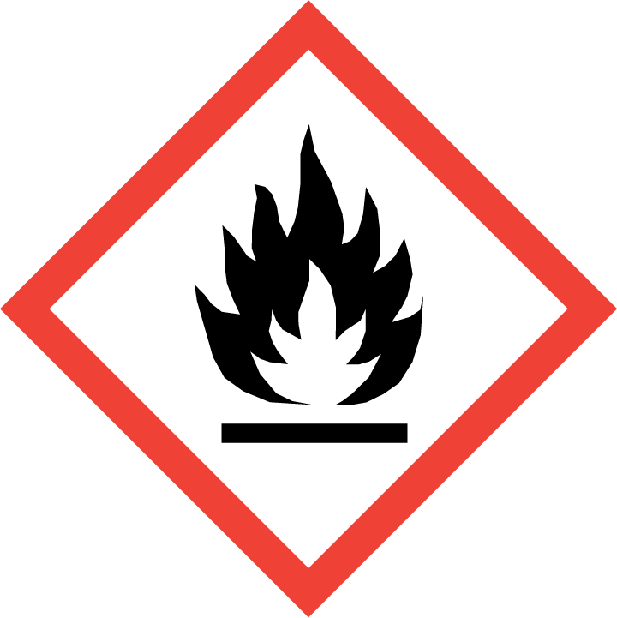 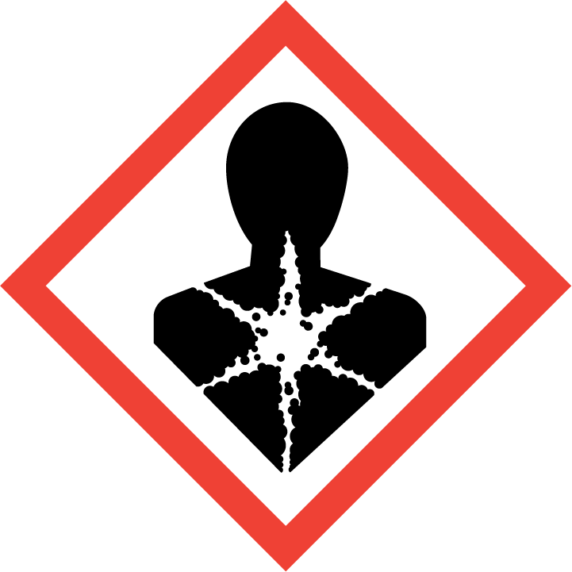 

Signal word : DANGER

Hazard statement :

H225- Highly flammable liquid and vapour

H315- Causes skin irritation.

H361d- Suspected of damaging fertility or the unborn child.

H336- May cause drowsiness or dizziness.

H373- May cause damage to organs through prolonged or repeated exposure.

H304- May be fatal if swallowed and enters airways.

Precautionary statement:

Prevention :

P201- Obtain special instructions before use.

P202- Do not handle until all safety precautions have been read and understood.

P210- Keep away from heat/sparks/open flames/hot surfaces. - No smoking.

P233- Keep container tightly closed.

P240- Ground/bond container and receiving equipment.

P241- Use explosion-proof electrical/ventilating/lighting/equipment.

P242- Use only non-sparking tools.

P243- Take precautionary measures against static discharge.

understood.

P260- Do not breathe dust/fume/gas/mist/vapours/spray.

P264- Wash hands thoroughly after handling.

P271- Use only outdoors or in a well-ventilated area.

P280- Wear protective gloves/protective clothing/eye protection/face protection.

Response :

P303+ P361+ P353- IF ON SKIN (or hair) Remove/Take off immediately all contaminated clothing. Rinse skin with water/shower.

P370+ P378- In case of fire Use carbon dioxide, dry chemical or foam for extinction.

P302 + P352- IF ON SKIN Wash with plenty of soap and water.

P332+P313- If skin irritation occurs. Get medical advice/ attention.

P362+ P364- Take off contaminated clothing and wash before reuse.

P308+ P313- IF exposed or concerned Get medical advice/attention.

P304+ P340- IF INHALED Remove victim to fresh air and keep at rest in a position comfortable for breathing.

P312 - Call a POISON CENTER or doctor/physician if you feel unwell.

P314- Get medical advice/attention if you feel unwell.

P301+ P310- IF SWALLOWED Immediately call a POISON CENTER or doctor/physician.

P331- Do NOT induce vomiting.

Storage :

P403+P233- Store in a well-ventilated place. Keep container tightly

closed.

P235- Keep cool.

P405- Store locked up.

Disposal :

P501- Disposal of contents / container in accordance with national

regulations.

**2.3. Other hazards**

None known

**3. Composition/information on ingredients**

**3.1. Substance**

**-**

**3.2. Mixture**

Information on ingredients / Hazardous components

|  |  |  |  |
| --- | --- | --- | --- |
| Chemical Name | CAS-No | Concentration (%) | Classification GHS |
| Toluene | 108-88-3 | 85 | Flam Liq.2, H225  Skin Irrit.2, H315  Asp.Tox.1, H304  STOT-SE.3, H336  STOT-RE.2, H373  Repr .2, H361d.  (https://echa.europa.eu/brief-profile/-/briefprofile/100.003.297) |
| Polyacrylate resin | 25852-37-3 | 15 | Not classified.  (https://echa.europa.eu/substance-information/) |

**4. First aid measures**

**4.1. Description of first aid measures**

General advice : If medical advice is needed, provide SDS document to physician.

Inhalation : Remove the victim from exposure or move to well- ventilated area. If there is difficulty in breathing, medical advice is required.

Skin contact : After contact with skin, wash with plenty of soap and water.

Remove contaminated clothing, shoes and leather accessories.

Eye contact : Rinse cautiously with water for several minutes. Remove contact lenses, if present and easy to do. Continue rinsing. Immediately call a POISON CENTER or doctor/ physician.

Ingestion : In case of swallowing, rinse mouth with water, drink plenty of water. If feel unwell, seek medical advice.

**4.2. Most important symptoms and effects, both acute and delayed**

Symptoms : no special hints

**4.3. Indication of any immediate medical attention and special treatment needed**

Treat symptomatically.

**5. Fire-fighting measures**

**5.1. Extinguishing media**

Suitable extinguishing media : fine water spray, foam, dry powder, CO 2

Unsuitable extinguishing media : no data available.

**5.2. Special hazards arising from the substance or mixture**

Highly flammable liquid and vapour.Vapours are heavier than air and may spread along floors.Vapours can form explosive mixtures with air.Vapours can travel considerable distances to a source of ignition where they can ignite, flash back or explode.Container may explode if heated.

In the event of fire the following can be released: carbon monoxide, carbon dioxide.

**5.3. Advice for firefighters**

On burning will emit toxic fumes, fire fighter should wear self-contained breathing apparatus and suitable protective clothing if risk of exposure to vapor or product of combustion.

**6. Accidental release measures**

**6.1. Personal precautions, protective equipment and emergency procedures**

Use personal protective equipment. Avoid slippery, do not touch or walk through spilled material.

**6.2. Environmental precautions**

Take up and fill into a closable container. Prevent run off into drains and waterways.

**6.3. Methods and material for containment and cleaning up**

Take up liquid spill into absorbent material, eg: soil, sand and other non-flammable absorbent

material.

**7. Handling and storage**

**7.1. Precautions for safe handling**

Advice on safe : wear protective equipment, wear safety goggles when working.

handling

Hygiene measures : Do not eat, drink or smoke when working. Wash hands before

breaks and after work.

General protective : Do not inhale gases/ vapors/ aerosols. Avoid contact with eyes and

measures skin.

**7.2. Condition for safe storage, including any incompatibilities**

**Prevention of fire and explosion**

Information : no special measures required.

**Storage**

Information : none

Further Information on storage conditions:

Keep container tightly closed and store in a cool, dry well- ventilated location. Store away from heat, flames, ignition sources and incompatibles.Avoid contact with strong acids, alkalis, oxidizing agents, rubber and plastics. Check regularly for leaks.

**8. Exposure controls / Personal protection**

**8.1. Control parameters**

Exposure limit(s) :

|  |  |  |  |  |
| --- | --- | --- | --- | --- |
| Ingredient | CAS-No | Statutory basis | Value type (From of exposure; Expressed as) | Occupational exposure limit |
| Toluene | 108-88-3 | (Decision.No.3733/2002/QD-BYT) | TWA | 100 mg/m3 |
| 108-88-3 | (Decision.No.3733/2002/QD-BYT) | STEL | 300 mg/m3 |

**8.2. Exposure controls**

Appropriate : operate in well- ventilated area.

engineering controls

Personal protective equipment

**Eye protection : wear safety goggles.**

Hand protection : protective gloves.

Body protection : protective working clothes and safety shoes.

Respiratory protection : wear respirator

Hygiene measures : keep away from foodstuff. Always wash hands before eating, drinking, smoking. Wash contaminated clothing and other protective equipment before storage or re-use.

**9. Physical and chemical properties**

**9.1. Information on basic physical and chemical properties**

Physical state or appearance: viscous liquid

Color : colorless to slight yellowish.

Odor : characteristic.

Odor Threshold : no data available.

pH of liquid (25°c) : no data available

Melting point : no data available.

Boiling point : no data available.

Flash point : 5°c closed cup

Evaporation rate : no data available.

Flammability : no data available.

Upper Explosion/Ignition limit: no data available.

Lower explosion limit : no data available.

Vapor pressure : no data available.

Relative vapor : no data available.

Relative density : no data available.

Solubility : soluble in water.

Partition coefficient : no data available.

(n-octanol/water)

Autoignition : no data available.

temperature

Thermal : no data available.

decomposition

Viscosity, kinematic : no data available.

Viscosity, Dynamic : no data available.

Oxidizing properties : no data available.

**9.2. Other Information**

Density : no data available.

Metal corrosion : no data available.

**10. Stability and reactivity**

**10.1. Reactivity**

Highly flammable liquid and vapour.

**10.2. Chemical stability**

The product is stable under normal conditions.

**10.3. Possibility of hazardous reactions**

Vapour may form explosive mixture with air.

**10.4 Conditions to avoid**

Heat, flames, ignition sources and incompatibles. See section 7.

**10.5. Incompatible materials**

Avoid contact with strong acids, alkalis and oxidizing agents.

**10.6 Hazardous decomposition products**

Carbon dioxide, carbon monoxide may form when heated to decomposition.

**11. Toxicological information**

**11.1. Information on toxicological effects**

Acute toxicity (oral) : not classified.

Acute toxicity : not classified.

(inhalation)

Acute toxicity (dermal) : not classified.

Irritation/corrosion : Causes skin irritation.

of the skin

Serious eye damage/ : not classified.

eye irritation

Repeated dose toxicity : not classified.

**CMR assessment**

Carcinogenicity : not classified.

Mutagenicity : not classified.

Teratogenicity : not classified.

Toxicity to reproduction: Suspected of damaging fertility or the unborn child.

Specific Target Organ : May cause drowsiness or dizziness.

Toxicity-single exposure

Specific Target Organ: May cause damage to organs through prolonged or repeated exposure. Toxicity-Repeated exposure

Aspiration hazard : May be fatal if swallowed and enters airways.

**12. Ecological information**

**12.1. Ecotoxicity**

No data available.

**12.2. Persistence and degradability**

Biodegradability (BOD5/ COD): No data available.

Biochemical oxygen demand (BOD5): No data available.

Chemical oxygen demand (COD): No data available.

**12.3. Bioaccumulative potential**

No data available.

**12.4. Mobility in soil**

No data available.

**12.5. Other adverse effects**

No data available.

**13. Disposal considerations**

**13.1 Waste treatment methods**

Waste from residue: Disposal should be in accordance with local regulations and legislation.

Contaminated packaging: Dispose of empty contaminated containers in accordance with

regulations and legislation.

**14. Transport information**

**D.O.T Road/Rail**

UN number : not applicable.

UN Proper Shipping Name: not applicable.

Hazard label: 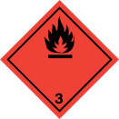

Transport hazard class(es): 3.

. Packing group : II.

Environmental hazards (Marine pollutant): not applicable.

Transport in bulk : not applicable.

. Special precaution for user: not applicable.

**Air transport ICAO-TI/IATA-DGR**

. UN number : not applicable.

UN proper shipping name: not applicable.

Hazard label: 

Transport hazard class(es): 3

Packing group : II

Environmental hazards : not applicable.

Transport in bulk : not applicable.

. Special precaution for user: not applicable.

**Sea transport IMDG**

UN number : not applicable.

UN proper shipping name: not applicable.

Hazard label: 

Transport hazard class(es): 3

Packing group : II

Environmental hazards (Marine pollutant): not applicable.

Transport in bulk : not applicable.

Special precaution for user: not applicable.

**15. Regulatory information**

**15.1 Safety, health and environmental regulations/ legislation specific for the**

**substance or mixture.**

* Regulation on classification and labeling of chemicals - Number 04/2012/TT-BCT - Date issued :13/02/2012
* Regulations on the list of hazardous industrial goods to be packed in the process of transporting and transporting dangerous industrial goods by road, rail and inland waterway transport - number: 44/2012/TT-BCT - Date issued 28/12/2012
* National technical standard for ambient air quality - QCVN05:2013/BTNMT
* National technical regulation on some hazardous substances in the surrounding air - QCVN06:2009/BTNMT
* Decision, No.3733/2002/QD-BYT.

**16. Other information**

The information in the sheet were written based on the best knowledge and experience

currently available but without liability.

SDS prepared on: June 15, 2018

Revision date : Nov 14, 2020.

Version 1.0

Legend

TWA: Time Weighted Average

IATA: International Air Transport Association

ICAO: International Civil Aviation Organization

IMDG: International Maritime Dangerous Goods

Flam Liq.2: flammable liquid, category 2.

Skin Irrit.2: skin irritation, hazard category 2.

STOT-SE.3: Specific target organ toxicity- Single exposure, Category 3

STOT-RE.2: Specific target organ toxicity- Repeated exposure: Category 2

Asp.Tox.1: Aspiration Toxicity, Category 1.

Repr .2: Reproductive toxicity, Category 2.